**Eclipse:**

Step 1: File -> Project..

Step 2: Type Maven

Step 3: Select Maven Project

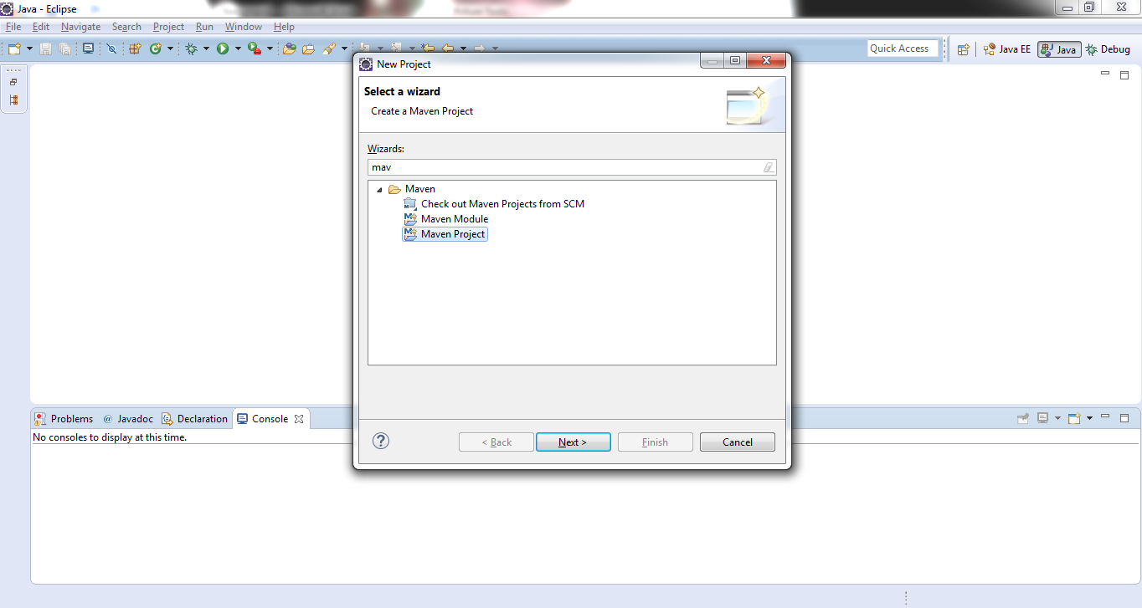

Step 4: Click next button

Step 5: Select top check box as mentioned in below screenshot

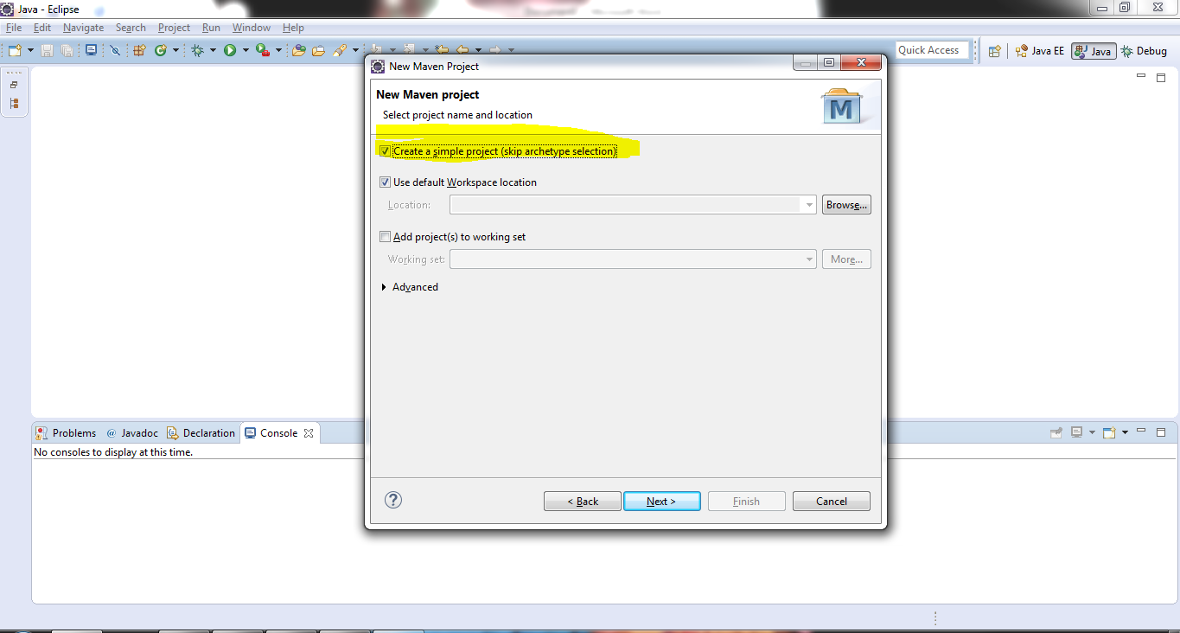

Step 6: Click Next button

Step 7: Enter groupid and artifactid and click on Finish button

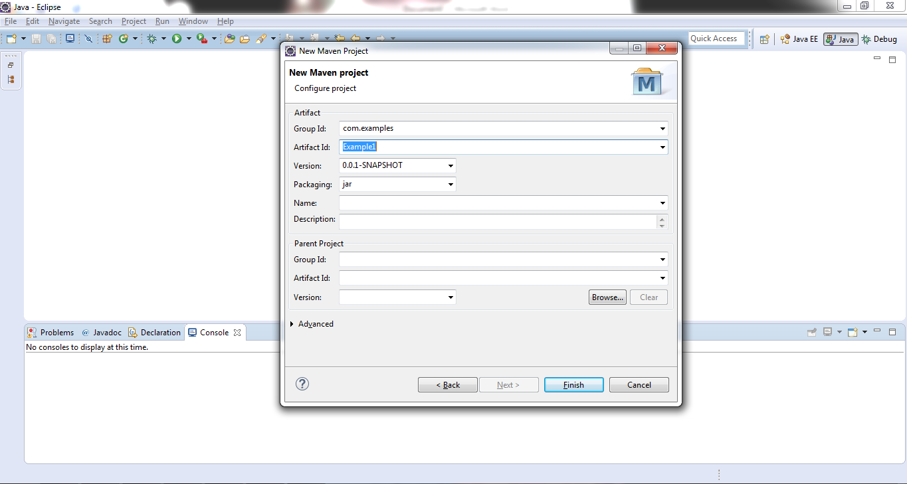

Step 8: Example1 project will be created

